3D Generative-Adversarial Modeling of Electron Microscope Images of Protein Complexes

November 2018

Mark Rozanov

markroza@tau.ac.il

marik.s79@gmail.com

314059098

1 Abstract

**Main Task** We propose to learn the non-linear mapping from atomic protein structures to images obtained from an electron microscope at medium resolution ( 6A). In the first phase we will train GAN on fixed size patches of protein structures (structure fragments).

**Possible Extension** Create a map of entire biomolecular complex using 3D fully convolutional neural network (FCN),

**Possible Extension 2** Start from list of atoms, protein structure. It contains atoms in chain (ordered) and neighborhood atoms not in a chain (unordered).

2 The Proposal

**input of the final trained system:** 3D image of protein structure fragment - Figure 1

**output of the nal trained system:** Synthetic EM image of the fragment - Figure 2. 3D matrix of dimension 20^3

**proposed method** We will start by implementing 3D-VAE-GAN from [4] with some adjustments :.

• The input to the image encoder is 20^3 RGB 3D image

• The output of the generator is 20^3 3D black and white image

• We will add the gradient difference loss (GDL) function in the generator training as in [2] and [3].

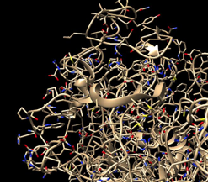

Figure 1: 3D image of protein Structure Fragment

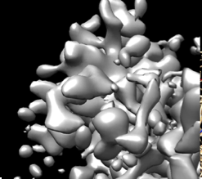

Figure 2: Fragment of EM map, resolution 6.1 A

**novelty** To the best of our knowledge, this is the first application of the GAN framework in the eld of synthetic cryo EMl image generation.

**evaluation** As an additional evaluation of the quality of a generated fragment map, we will generate a map of entire molecular complex. The complex structure will be divided to overlapping patches and a cryo-EM map will be generated using the pretrained GAN. A map of the complex is an average of the map of fragments.

**existing code** 3D-VAE-GAN implementation is available from github: https:

//github.com/Spartey/3D-VAE-GAN-Deep-Learning-Project

**dataset** The Electron Microscopy Data Bank (EMDB) at PDBe. (http:// www.ebi.ac.uk/pdbe/emdb/index.html/) [1] contains pairs of EM images with corresponding structures

References

[1] Lawson, C. L., Patwardhan, A., Baker, M. L., Hryc, C., Garcia, E. S., Hudson, B. P., Lagerstedt, I., Ludtke, S. J., Pintilie, G., Sala, R., Westbrook, J. D., Berman, H. M., Kleywegt, G. J., and Chiu, W. EMDataBank uni ed data resource for 3DEM. Nucleic Acids Research (2016).

[2] Mathieu, M., Couprie, C., and LeCun, Y. Deep multi-scale video prediction beyond mean square error.

[3] Shin, H. C., Roth, H. R., Gao, M., Lu, L., Xu, Z., Nogues, I., Yao, J., Mollura, D., and Summers, R. M. Deep Convolutional Neural Net-works for Computer-Aided Detection: CNN Architectures, Dataset Char-acteristics and Transfer Learning. IEEE Transactions on Medical Imaging (2016).

[4] Wu, J., Zhang, C., Xue, T., Freeman, W. T., and Tenenbaum, J. B. Learning a Probabilistic Latent Space of Object Shapes via 3D Generative-Adversarial Modeling. Tech. rep.

3